Ava Gustin  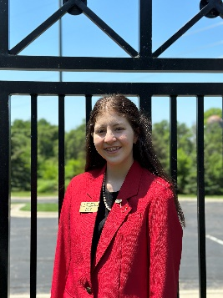 | Hello Kansas! My name is Ava Gustin, and I am a Junior at Mission Valley High School located in Eskridge, Kansas. This year, I am serving as the Kansas FCCLA State President. I can’t wait to interact with you, and help you build your leadership! I love being involved in FCCLA as well as participating in activities like Volleyball, Book Club, Student Council, FFA, SAFE and 4-H. My favorite hobbies include baking, listening to music and reading and caring for my houseplants. I have a wide range of interests, so we probably have something in common! Reach out to me any time with my email. I can’t wait for this year in FCCLA, and I know Kansas FCCLA members are ready for the Ultimate Leadership Experience!
Madelyn Heigert  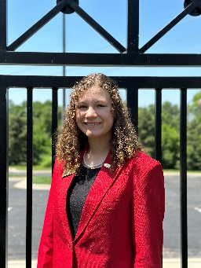 | Hey, Kansas FCCLA! I’m Madelyn Heigert and I am your 2023-24 Kansas 1st Vice President from St. Marys High School in St. Marys, Kansas! Outside of FCCLA, I am involved in the National Honor Society, FFA, Student Council, Debate, and Forensics. I love competing in STAR events, attending leadership conferences, and meeting all of the amazing people within FCCLA. This organization is so much more than just an organization, it's a family! Through FCCLA I want to be able to help you reach your goals, dreams, and aspirations. Together we can continue to make FCCLA the ultimate leadership experience!
Benjamin Dome  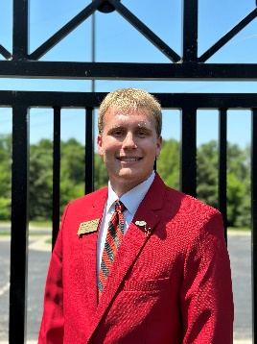 | Hi Kansas FCCLA! I am your 2023-2024 VP of Individual Programs, Benjamin Dome. I am beyond honored to serve you this year. As a sophomore at Victoria High School, I am involved in many activities. Apart from being an FCCLA member for 2 years, I am also involved in SAFE, FFA, and a sprinter on the track team. Outside of school, I am on the Heartland Community Foundation Youth Action Council, The Hays Arts Council Board of Directors, and the Options Center for Abuse volunteer team. Beyond those activities, I enjoy working as an intern at The Downtown Hays Development Corporation, sipping coffee with my friends, and listening to Taylor Swift. I cannot wait to meet every one of you and assist you in being your best self this year!
Easton Hrabe  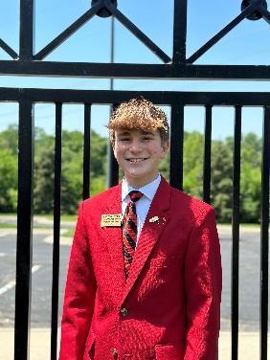 | Hey Kansas FCCLA! My name is Easton Hrabe and I’m your 2023-2024 Vice President of Public Relations. I will be sure to keep you all in the know as we shoot this award-winning film! As we go into the year, I am a Junior at Smith Center Jr./Sr. High School. I enjoy spending my time in FCCLA as well as other organizations such as Scholar’s Bowl, Forensics, FFA and Student Council. Aside from my organizations I love spending time with my family and friends. I can’t wait to see what this year holds as we watch from behind the scenes!
Levi Gleason  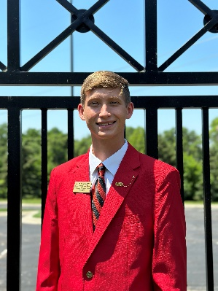 | Hey, Hey Kansas FCCLA! My name is Levi Gleason and I’m your 2023-2024 Vice President of Corporate Relations and Finance. This school year, I am a Senior at Hoxie High School. Coming from a town in western Kansas I am SO excited to meet you all and help connect big city and small town FCCLA like never before. While FCCLA is by far the most IncREDible organization I am a part of, some other areas you might find me. For example, I keep busy with my duties as journalism editor, class STUCO Rep, and as a participant in track, cross country, and swim! If I find a break in my schedule you might catch me heading outside for a walk, taking in one the beautiful Kansas sunsets. Reach out to me anytime
Asher Swank  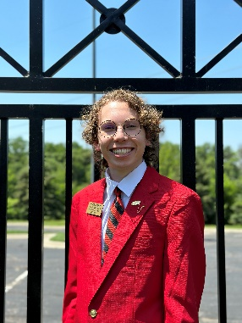 | Hello Kansas FCCLA! I’m Asher Swank, your 2023-24 Vice President of Peer Education. I am going into my Senior year at Southeast of Saline HS. I have been involved in FCCLA all 3 years of high school and participated in Star Events all 3 years. FCCLA has shaped me into who I am today, and I want to give others the opportunity to grow with FCCLA as well. Outside of FCCLA I am involved in FBLA, NHS, STUCO, Scholars’ Bowl, and Band. I enjoy traveling and meeting new people along the way. I can’t wait to meet new FCCLA friends and look forward to seeing you at FCCLA events. Let's make this an incREDible year with FCCLA.
Jaelyn Gaston  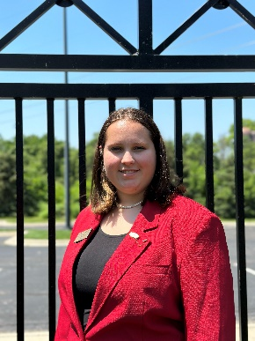 | Hello Kansas FCCLA! My name is Jaelyn Gaston, and I am your 2023-2024 Vice President of Recognition. I am going to be a Senior at Holton High School this school year. Along with FCCLA I am also very involved in other organizations in my school like Seatbelts Are For Everyone, Resist, Jackson County Youth Coalition, National Honor Society, and I am a Wildcat Ambassador for new students. When I am not doing things within my school, I am usually spending time with family and friends or working. I love traveling with my family, trying new things, and just spending quality time with them. I have worked at our local coffee shop, Penny’s, for the past 2 ½ years, and I babysit younger cousins all summer long. Along with all the busyness of life, I enjoy the new experiences FCCLA gives me the most. I can't wait to meet all of you and to be your VP of Recognition!
Vivian Reynolds  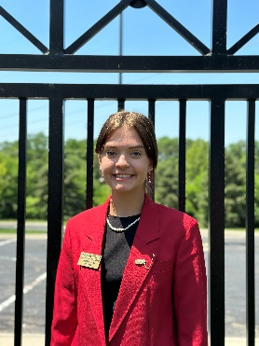 | Hey Kansas FCCLA! I am Vivian Reynolds and I am the Kansas State Vice President of Membership! I go to Royal Valley High School, and this will be my fourth year in FCCLA. Outside of FCCLA I am involved in Yearbook, Student council, National Honors Society, Theater, Jackson County Youth Coalition, Seatbelts Are for Everyone, and I am the Art club president. I am a cheerleader, and love to run track, golf, and plan to wrestle in the 2023-2024 school year. When I have a little free time, I enjoy listening to music, being with my friends, studying Spanish and French, and anything arts and crafts! I am so pumped up for this year and can’t wait for it to begin! This will be a great year, so get excited!

